EX.NO:2
Insert Records
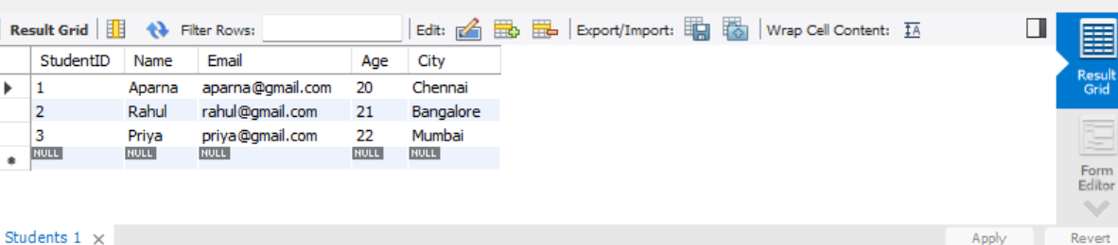

The INSERT command is used to insert records into the Students table. Here, three student records have been inserted with StudentID, Name, Email, Age, and City. The output displays the inserted records successfully.
Output: Three student records are displayed in the Students table.
Result: Thus, the records were successfully inserted into the Students table.

